**Name: Soumyadeep Ganguly**

**Reg. No.: 24MDT0082**

**Assignment #01**

**Algorithmic Problem Solving and Python Basics**

1. **A Happy Number is a number that eventually reaches 1 when replaced by the sum of the squares of its digits. For example, 19 is a happy number because 12 + 92 = 82, and 82 + 22 = 68, and 62 +82 = 100, and finally, 12 +02 +02 = 1.**

**Write the pseudocode and draw the flowchart for verifying whether a number is Happy Number or not?**

**Pseudo code:**

x 🡨 input(“Enter a number”)

sum 🡨 0

n 🡨 x

while n != 1 and n != 4:

while n > 0:

digit 🡨 reminder(n, 10)

n 🡨 coefficient (n, 10)

sum 🡨 sum + square(digit)

end

n 🡨 sum

sum 🡨 0

end

if n = 1:

output(“Given number is a happy number”)

else:

output(“Given number is not a happy number”)

end

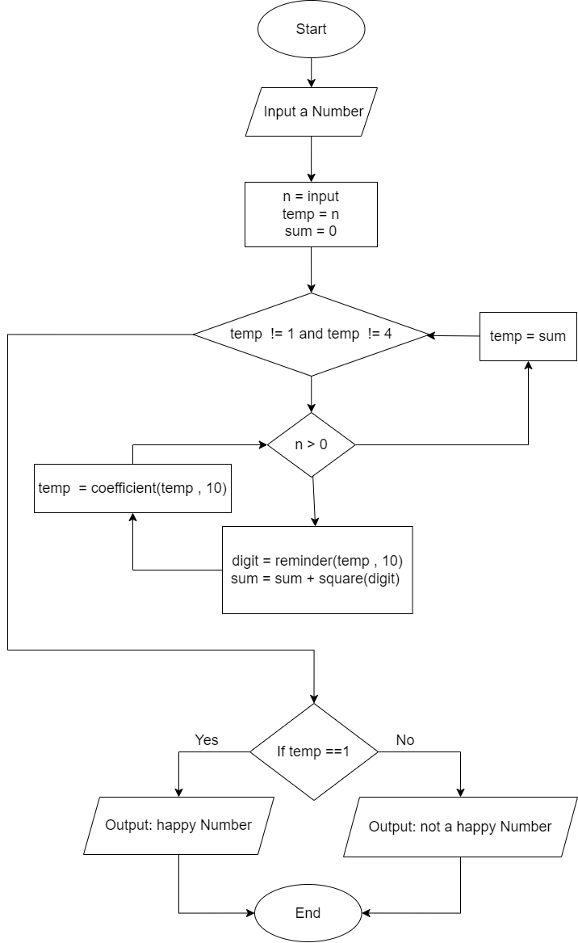**Flowchart:**

1. **Write a Python program which prints the following pattern.**

* * * * * *

* * * * *

* * *

* *

*

*

* *

* * *

* * * *

* * * * * *

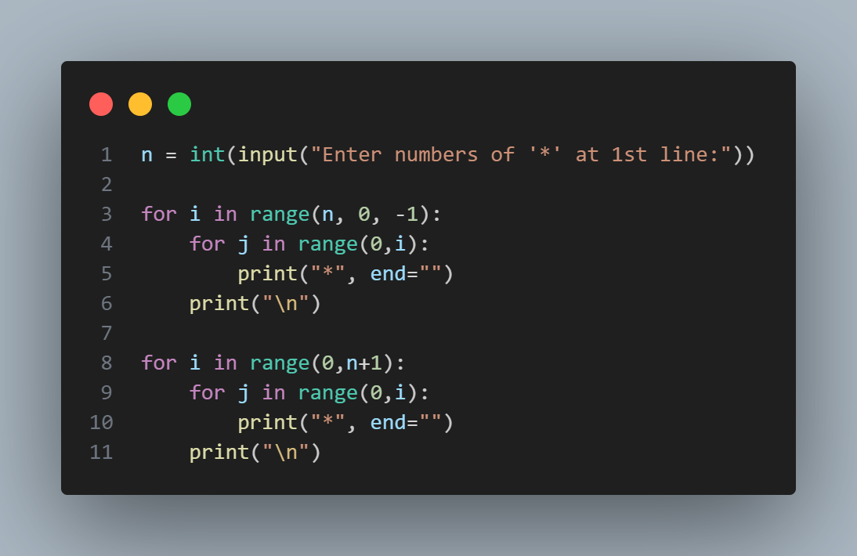

**Code:**

**Output:**

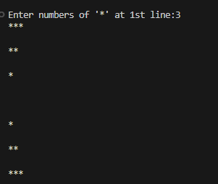

1. **Write a Python program, which takes a alphanumeric string as input from the user and outputs the string in which the charcater words only reverses. For example if the input is “1234abcd” then the out put should be “1234dcba” and if the input is “abcd1234” then the output is “dcba4321” and if the input is “ab12cde345fg6” then the output should be “ba21edc543gf6”.**

**Code:**

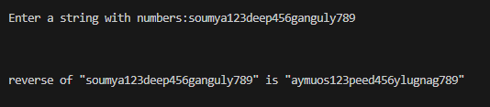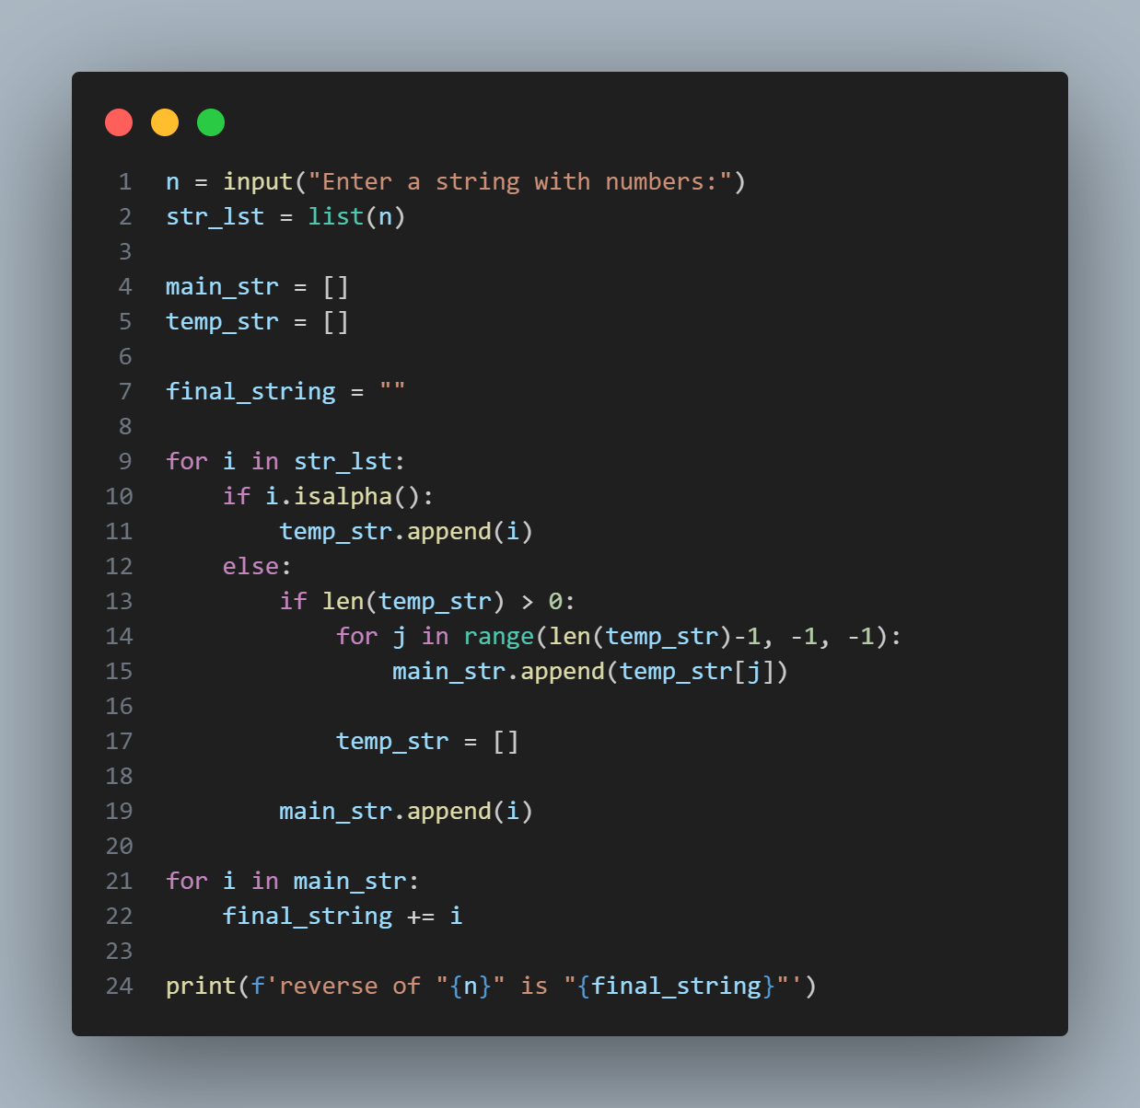

**Output:**